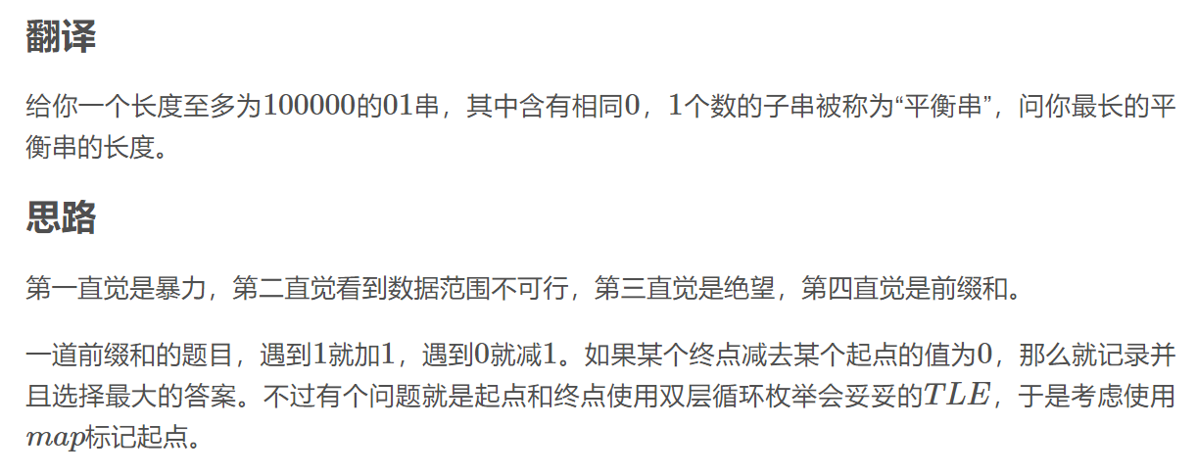

注意_map[0]为-1！！！这是因为字符串下标从0开始导致的

#include<cstdio>

#include<set>

#include<cstring>

#include<map>

#include<iostream>

#define fre freopen("input.txt","r",stdin);

using namespace std;

int main()

{

// fre;

int n;

cin>>n;

string s;

cin>>s;

map<int,int>_map;

int len=s.length();

int ans(0);

int sum(0);

_map[0]=-1;

for(int i=0;i<len;i++)

{

if(s[i]=='1')sum++;

else sum--;

if(_map.find(sum)==_map.end())

_map[sum]=i;

else ans=max(ans,i-_map[sum]);

}

cout<<ans<<endl;

return 0;

}

下标从1开始的

#include<cstdio>

#include<set>

#include<cstring>

#include<map>

#include<iostream>

#define fre freopen("input.txt","r",stdin);

using namespace std;

int main()

{

// fre;

int n;

cin>>n;

string s;

cin>>s;

s=" "+s;

map<int,int>_map;

int len=s.length()-1;

int ans(0);

int sum(0);

_map[0]=0;

for(int i=1;i<=len;i++)

{

if(s[i]=='1')sum++;

else sum--;

if(_map.find(sum)==_map.end())

_map[sum]=i;

else ans=max(ans,i-_map[sum]);

}

cout<<ans<<endl;

return 0;

}